
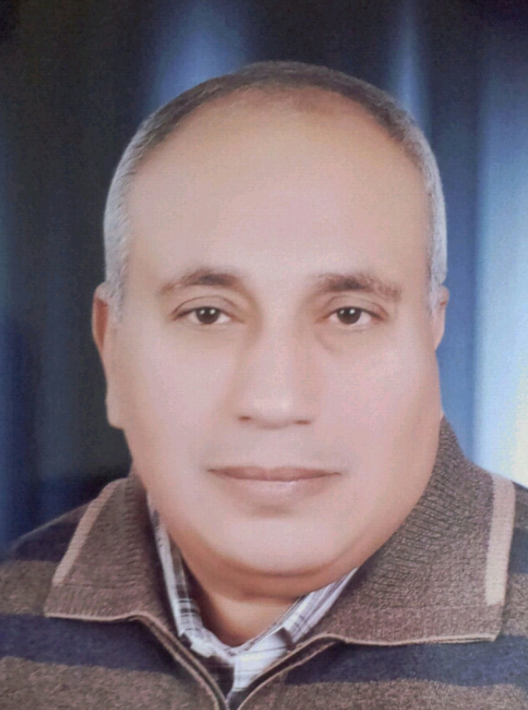

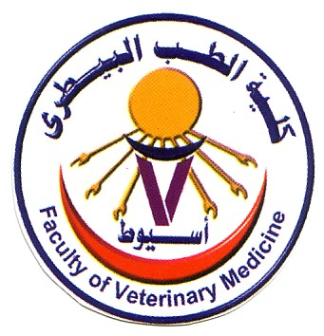
Assiut University
Faculty Veterinary Medicine
Department Poultry Diseases

**********************************************************************************

Curriculum Vitae
Name: Ragab Sayed Ibrahim
Date of birth: 1/12/1962

Nationality: Egyptian
Language: Arabic, English and Japanese in order
************************************************************************************************************

Scientific transcript
- B.V.Sc., Faculty Veterinary Medicine, Assiut University (1985).
- M.V.Sc. (poultry diseases), Faculty Veterinary Medicine, Assiut University (1991). Title: “Some Studies On Avian Pasteurellosis”.
- Ph.D. . (Poultry diseases), Channel program between Nippon Veterinary and Animal Science University, Tokyo, Japan and Faculty of Veterinary Medicine, Assiut University (1996). Title: “Epidemiological and Immunological Studies on Avian Pasteurella multocida isolates”.
************************************************************************************************************

Career Transcript
- Demonstrator: Dept. Poultry Diseases, Faculty Veterinary Medicine, Assiut University (1986-1991).
- Assistant lecturer: Dept. Poultry Diseases, Faculty Veterinary Medicine, Assiut University (1991-1996).
- Lecturer: Dept. Poultry Diseases, Faculty Veterinary Medicine, Assiut University (1996-2001).
- Assistant Professor: Dept. Poultry Diseases, Faculty Veterinary Medicine, Assiut University (2001-2006).
- Professor: Dept. Poultry Diseases, Faculty Veterinary Medicine, Assiut University (2006-till now).
- Supervisor: Molecular biology center, Assiut University (2001-2005).
************************************************************************************************************

Experiences
  - Member of organizing committee of Scientific Congress of Fac.Vet. Med., Assiut Univ.
  - Member of 5th scientific conference of Egyptian Veterinary Poultry Association.
  - Laboratory diagnosis of viral and bacterial infections.
  - Experience in the field of epidemiology with special regards to poultry diseases.
  - Consultant for diagnosis and control of poultry diseases.
  - Working as poultry diseases specialist at veterinary diagnostic laboratory, Ministry of agriculture, Kingdom of Saudi Arabia.
  - Teaching of undergraduate and postgraduate courses regarding to poultry diseases.
  - Supervising several M.V.Sc. and Ph.D. thesis in the field of poultry diseases.
  - Supervisor at Molecular Biology Research Center, Assiut University (1997-2005).
  - Preparation and carrying out different workshops on different molecular techniques.
  - Experience in some aspects of molecular biology.
  - Member of Environment Committee of Fac. Vet. Med., Assiut University.
  - Vice Manager of Data Base Project of Geographical Epidemiology at Assiut Governorate.
  - Member of Quality Assurance and Accreditation Project committee, Fac. Vet. Med., Assiut University.
  - Member of team work of Molecular Genetic Map project of Avian Influenza at Assiut Governorate
  - Member of Scientific Committee for Promotion of Professors and Assistant Professors, Cairo, Egypt.
************************************************************************************************************
Address: Assiut University, Faculty Veterinary Medicine, Department of Poultry Diseases, Assiut, Egypt.
Fax: 088-2080501 Assiut.
Tel: Work: 088-2080699 - 088-2080938
Home: 088-2321674 Mobile: 01005222622
E. Mail: ali196231@yahoo.com

